PARTNERS FOR RECREATION & CONSERVATION (PARC)
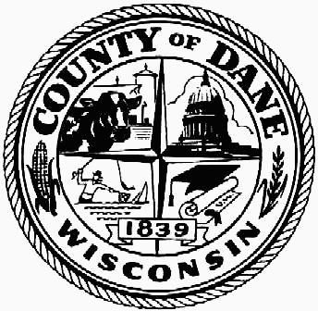

The Partners for Recreation & Conservation Grant Program provides capital assistance for outdoor recreation or conservation projects. These projects will be in partnership with local units of government or organizations dedicated to outdoor recreation or conservation. It was established as part of Dane County Executive Kathleen Falk’s 2011 budget with initial funding of up to $1 million.

Who may apply?
The sponsor must be a local government or nonprofit organization with the capacity to plan, implement, and maintain the project.

What projects are eligible?
Grants will be awarded for conservation or recreation projects that restore or improve a natural resource or an outdoor recreational facility to create a demonstrable, regional benefit.

How much funding is available?
The maximum amount of assistance to any one project will be $250,000 and the amount can be no more than 50% of the costs of the project. Acceptable grant match includes sponsor contributions, state or federal grants, private donations, or other financial contributions. Non-cash match will not be accepted: for example, donated services, labor (i.e. salary and fringe benefits), materials and supplies.

How to apply?
Beginning January 19, 2011, applications will be accepted on an ongoing basis. There is no application deadline. Discussing projects with staff before submitting an application is strongly encouraged, especially to help determine whether the proposed project is considered to have a regional benefit. Applications will only be accepted for conservation or outdoor recreation projects that demonstrate a regional benefit.
The application should include:
- Narrative that describes the project and its regional benefits
- Project maps or plans
- Estimated cost, grant request amount, and sources of financial match
- Time schedule for project
- Partnerships and/or Letters of Support

Submit applications to Sara Kwitek, Land & Water Resources Department, 1 Fen Oak Court, #223, Madison, WI 53718. Applications can also be emailed to Sara at Kwitek@countyofdane.com or faxed at 608-224-3745.

Grant Awards
The Park Commission will review applications and recommend grants to the County Board and County Executive for approval. This process will take approximately 2 – 3 months from the time applications are submitted. Sponsors may be contacted by staff or asked to attend a Park Commission meeting to answer questions or provide additional information or background on the proposed project.

Grant Payments and Requirements
Grants will be dispersed on a reimbursement basis unless otherwise approved. Successful applicants must give recognition to Dane County’s contribution on any signage or by other means as appropriate. In addition, projects funded through the program must be open for public use. These requirements and possibly others as appropriate will be outlined in a grant agreement between the sponsor and the County. Work on the project must be initiated and completed within the time schedule of the signed grant agreement. Project extensions may be granted upon request.

Questions?
Contact Sara Kwitek, Acquisition and Planning Specialist, at 224-3611 or Kwitek@countyofdane.com.

